

[Accredited by NAAC & NBA, Approved by AICTE New Delhi & Permanently Affiliated to JNTUH]

**DEPARTMENT OF ARTIFICIAL INTELLIGENCE**

Gesture Controlled Virtual Mouse and Keyboard using OpenCV

**II. ABSTRACT**

A gesture-controlled virtual mouse makes it easier for people to connect with computers by utilizing hand gestures, voice commands, and eye movements.Computers seldom ever require direct contact.Static and dynamic hand gestures, voice assistance, and eye motions can be used to virtually control all input and output processes.Modern machine learning and computer vision techniques are used in the project to recognise hand gestures, voice commands, and eye movements using both internal and external cameras.It uses a Convolutional Neural Network(CNN)-like model implemented by MediaPipe running on top of pybind11. It consists of two modules.The first works with your hand directly using MediaPipe's hand detection, while the second employs a glove with a single colour.By maneuvering fingers in air to access keyboard keys, users of the visual keyboard can work in the air. This is made possible by computer vision technology and artificial intelligence.To make the virtual keyboard function, we employ a variety of modules, including the Hand Tracking and CVzone Hand Detector Modules, as well as the Controller imported from the Pynput keyboard.The suggested system will function as a virtual keyboard and mouse without the necessity of a wire or any other external device.The webcam, which is the only piece of hardware in this system, is used to record images, recognise hand gestures, eye movements, and receive voice instructions using the Pyttsx3 module.

**III . INTRODUCTION**

An image or a videotape may be used as input to image processing, a subset of signal processing, and may be produced as an image or as various parameters of an imageOne type of image processing is the recognition and removal of shadows from gestures. Many different methods for gesture recognition have been put forth recently.Motion capture, human-computer interaction, and behavior analysis are just a few of the functions that hand tracking can perform.For hand motion detection and tracking, a variety of detectors and detection gloves are employed.Simple cameras that track motion and recognise gestures can be used in place of more expensive detectors.

Presently, video conferencing is incredibly common.Because of this, the majority of computer users utilize webcams, and most laptops come equipped with one as well.The suggested solution, which is webcam-based, may be appropriate to do away with the requirement for a mouse and keyboard.A fascinating & successful method of HCI(Human- Computer- Interaction) is the use of hand gestures when interacting with a computer. This subject has been researched quite well. Devices are becoming smaller and more portable as technology advances daily.Some gadgets are now wireless, while others are no longer in use.The system suggested in this study may eventually cause some devices to become inactive. That's the future of HCI (Human- Computer Interaction).The proposal aims to create a virtual mouse and keyboard that recognises gestures.The goal is to replace conventional bias with a simple camera that can control keyboard and mouse functionalities.The only tool the Virtual Mouse uses to connect the user and the machine is a camera. It enables the user to operate mouse functionalities while interacting with a machine without any mechanical or physical bias. Typically, we communicate with computers through a mouse, keyboard, or another device that is closely related to them. The user's naked hand is the only option for input while utilizing a webcam in this study; the wireless bias also requires a power source and connection technologies.It is therefore a genuinely interactive way to control the keyboard and mouse pointer. Both the standard mouse and machine remote controls could be replaced by this technology.The only barrier exists because of the illumination. Since the majority of computers are used in dimly lit environments, the system still can't be sufficient to replace the conventional mouse.People who have severe movement problems in particular may have physical limitations that severely restrict their ability to control their fine motor. they might not be able to participate in class and communicate using a standard keyboard and mouse.

In this work, we present a unique multimodal interactive keyboard and mouse system that uses the camera of the device to monitor and recognise hands in place of a typical keyboard and mouse. This is accomplished without the need for extra hardware by using a camera to capture inputs using a vision-based color identification technique and a hand gesture recognition technique.With the aid of our system, users will be able to use just one hand to control their computer's keyboard and mouse. The major goal of this research is to create a keyboard and mouse interface that allows persons with motion disabilities to interact with a computer's webcam using just one hand.

**IV .LITERATURE SURVEY**

**[1]. Virtual Mouse Control Using Colored Fingertips and Hand Gesture Recognition** [**Vantukala VishnuTeja Reddy**](https://ieeexplore.ieee.org/author/37088543107)**;** [**Thumma Dhyanchand**](https://ieeexplore.ieee.org/author/37088545865)**;** [**Galla Vamsi Krishna**](https://ieeexplore.ieee.org/author/37088547613)**;** [**Satish Maheshwaram**](https://ieeexplore.ieee.org/author/37706236100) **-2020 (DOI:**[**10.1109/HYDCON48903.2020.9242677**](https://ieeexplore.ieee.org/document/9242677)**)**

The implementation of a virtual mouse is done Based on a picture in a live video, with fingertip and hand gesture detection. It comprises two techniques for tracking fingers: hand gesture recognition and employing coloured caps. Detecting the contour and creating a convex hull around it allows for the monitoring of hand gestures.This process consists of three basic steps: tracking hand gestures, finger detection using color identification, and cursor implementation. The hand's features are retrieved using a constructed hull and contour area ratio.For different procedures, different combinations of the coloured caps are employed.Right click, double left click, single left click, and scrolling are all different mouse control actions.

**[2]. Real-time virtual mouse system using RGB-D images and fingertip detection** [**Dinh-Son Tran**](https://link.springer.com/article/10.1007/s11042-020-10156-5#auth-Dinh_Son-Tran) **;**

[**Ngoc-Huynh Ho**](https://link.springer.com/article/10.1007/s11042-020-10156-5#auth-Ngoc_Huynh-Ho)**;** [**Hyung-Jeong Yang**](https://link.springer.com/article/10.1007/s11042-020-10156-5#auth-Hyung_Jeong-Yang)**;** [**Soo-Hyung Kim**](https://link.springer.com/article/10.1007/s11042-020-10156-5#auth-Soo_Hyung-Kim) **&** [**Guee Sang Lee**](https://link.springer.com/article/10.1007/s11042-020-10156-5#auth-Guee_Sang-Lee)**-2020**

**(DOI:** [**https://doi.org/10.1007/s11042-020-10156-5**](https://doi.org/10.1007/s11042-020-10156-5)**)**

In this paper, a brand-new virtual-mouse technique that makes use of fingertip detection and RGB-D pictures is suggested. Using detailed skeleton-joint information photos from a Microsoft Kinect Sensor version 2, the hand region of interest and the palm's center are first retrieved, and they are then translated into a binary image. A border-tracing method is then used to extract and describe the hands' outlines. Based on the hand-contour coordinates, the K-cosine algorithm locates the fingertip. Finally, the mouse cursor is controlled via a virtual screen by mapping the fingertip location to RGB pictures. Using a single CPU and Kinect V2, the system tracks fingertips in real-time at 30 frames per second on a desktop computer. The trial outcomes demonstrated a high level of accuracy.The system can function effectively in real-world settings with just one CPU. Humans may readily connect with computers by hand thanks to this fingertip-based interface.

**[3]. A New Virtual Keyboard with Finger Gesture Recognition for AR/VR Devices** [**Tae-Ho Lee**](https://link.springer.com/chapter/10.1007/978-3-319-91250-9_5#auth-Tae_Ho-Lee) **&** [**Hyuk-Jae Lee**](https://link.springer.com/chapter/10.1007/978-3-319-91250-9_5#auth-Hyuk_Jae-Lee) **-2018**

**(DOI:**[**https://doi.org/10.1007/978-3-319-91250-9_5**](https://link.springer.com/chapter/10.1007/978-3-319-91250-9_5)**)**

Convex-Hull and keyboard layout optimization are used to create a virtual keyboard that uses a multi-tab approach of 3 4 arrays and is popular in mobile environments. A system that types the virtual keyboard by recognizing hand gestures in a single camera based environment.By strategically placing alphabetic keys in relation to how frequently characters appear, the keyboard layout is made more efficient. Definition speeds up typing by allowing users to recognise their own typing behavior. According to simulation data, the suggested virtual keyboard speeds up operations by an average of 46.16% when compared to the most common 'ABC' keyboard.The proposed type-in action for issuing commands with a virtual keyboard is effective, according to experimental data.The thumb making contact with the index finger while the index finger is pointing at the character to be picked is the new definition it suggests for the term "type-in action." A camera sensor can quickly identify this gesture.

**[4]. Deep Learning-Based Real-Time AI Virtual Mouse System Using Computer Vision to Avoid COVID-19 Spread S. Shriram,B. Nagaraj,J. Jaya,S. Shankar,and P. Ajay-2021**

**(DOI:** [**https://doi.org/10.1155/2021/8133076**](https://doi.org/10.1155/2021/8133076)**)**

In this suggested paper, a webcam or built-in camera is used to record hand motions and recognise hand tips using computer vision, removing the limitation of Bluetooth mice that are not free of devices due to utilization of battery for power.The primary goal of the suggested system is to replace the use of a typical mouse device with a web camera or a built-in camera in the computer to perform computer mouse pointer and scroll tasks. The system's algorithm makes use of the machine learning algorithm. The computer can be virtually controlled by hand movements to perform left-click, right-click, scrolling, and computer cursor activities in lieu of a physical mouse. The algorithm used to find the hands is built on deep learning. As a result, by eliminating human contact and the requirement for external devices to operate the computer, the suggested strategy will stop the spread of COVID-19.

**[5]. Hand gesture recognition-based non-touch character writing system on a virtual keyboard** [**Md. Abdur Rahim**](https://link.springer.com/article/10.1007/s11042-019-08448-6#auth-Md__Abdur-Rahim)**,** [**Jungpil Shin**](https://link.springer.com/article/10.1007/s11042-019-08448-6#auth-Jungpil-Shin) **&** [**Md. Rashedul Islam**](https://link.springer.com/article/10.1007/s11042-019-08448-6#auth-Md__Rashedul-Islam)**-2020**

**(DOI:**[**https://doi.org/10.1007/s11042-019-08448-6**](https://doi.org/10.1007/s11042-019-08448-6)**)**

The non-touch character writing system that is suggested in this paper enables users to engage with and control on-screen virtual keyboards in a safe and healthy manner by detecting a limited set of hand gestures. This work is divided into two sections: Recognition of hand gestures and gestural flick input utilizing a virtual keyboard are both possible. On the monitor is a user-friendly keyboard interface that employs the flick input technique. To extract the features of a gesture, CNN is employed in a deep learning method. Color segmentation is used to detect the hand and determine these properties. Color pixels can be produced by extracting a certain HSV (hue, saturation, value) from the input image and using threshold masking.In order to classify the hand motions more precisely, a support vector machine is used in the last step. The user inserts the character by viewing the virtual keyboard and performing non-touch character input using a gestural flick input technique. On the basis of the user's hand gestures being recognised, the character input is carried out. Character input is assessed based on input speed, accuracy, and the typical categorization accuracy of hand gestures and character recognition. The system is then evaluated against cutting-edge algorithms.

**[6] Computer Cursor Control Using Eye and Face Gestures** [**Akshada Dongre**](https://ieeexplore.ieee.org/author/37088535263) **Department of Information Technology, St. Francis Institute of Technology, Mumbai, India;** [**Rodney Pinto**](https://ieeexplore.ieee.org/author/37088532904)**;** [**Ameya Patkar**](https://ieeexplore.ieee.org/author/37088262830)**;** [**Minal Lopes**](https://ieeexplore.ieee.org/author/37088533313) **- 2020 (DOI:** [**https://ieeexplore.ieee.org/document/9225311**](https://ieeexplore.ieee.org/document/9225311)**)**

Face recognition is carried out in this system after real-time video input is analyzed following the user's input.A point on the user's face would operate the pointer on the screen, and a right or left wink would function as the right or left click, respectively. When viewing PDFs and other publications, constricted eyes would make it easier to activate the scroll feature.By using facial gestures, it would make it easier to utilize and move the pointer.The user is able to scroll, drag, and click while using this application, as well as move the cursor in any directions. Right-click and left-click functionality would be implemented by the left and right winks, respectively. Squinted eyes make it possible to scroll when viewing papers or files.The user's mouth opening would calculate the distance between the upper and lower lips and enable/disable the input while an anchor point on their face would control the pointer on the screen.

**V. EXISTING SYSTEM**

A technique is created where an algorithm is made to detect fingers, recognise motions, and control mouse activities. Along with a description of the overall system, this work is divided into three subsections: color identification, gesture identification, and virtual mouse control.

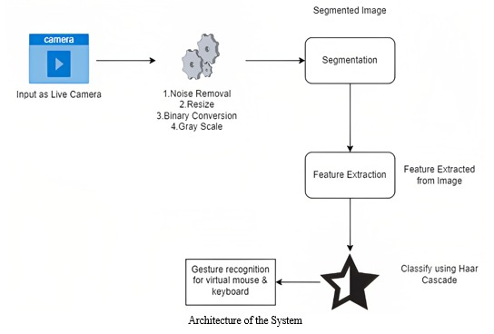 **Fig.1. Architecture of the system**

Fig. 1 presents the system's overall diagram. It is broken into two categories: "gesture recognition" and "fingertip detection" using coloured caps. It entails integrating the video and processing the photos through backdrop removal. By ignoring the steady items and only taking into account the foreground objects, background subtraction helps. Fingertip detection comprises finger guessing, circle recognition, and color identification. Gesture recognition entails identifying the skin tone, detecting contours, forming convex hulls, and finally inferring the gesture. The appropriate mouse operation can be carried. 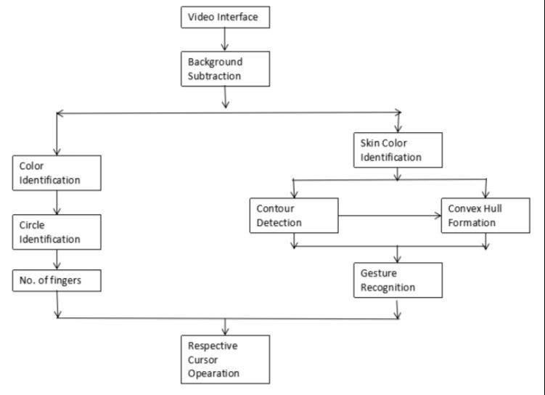

**Fig.2 Overall System Block Diagram**

**VI. PROPOSED SYSTEM**

The user's gesture can be caught in real time by the webcam in the suggested system, and then the process of implementation can begin. Next, the captured image will be subjected to a segmentation process to compare and separate the value of the pixels to the values of the defined color.

A webcam is used to gather the input data, which is then analyzed using the suggested model. There are five sections in the workflow:

* virtual keyboard and mouse
* a hand gesture recognition system and haar cascade classifier
* a gestural flick input
* Voice commands
* Eye movements

**Virtual Mouse**

By employing a built-in camera or web camera to follow the fingertip of the hand gesture, voice command, or eye movement, the AI virtual mouse system enables us to move the cursor and conduct mouse cursor actions.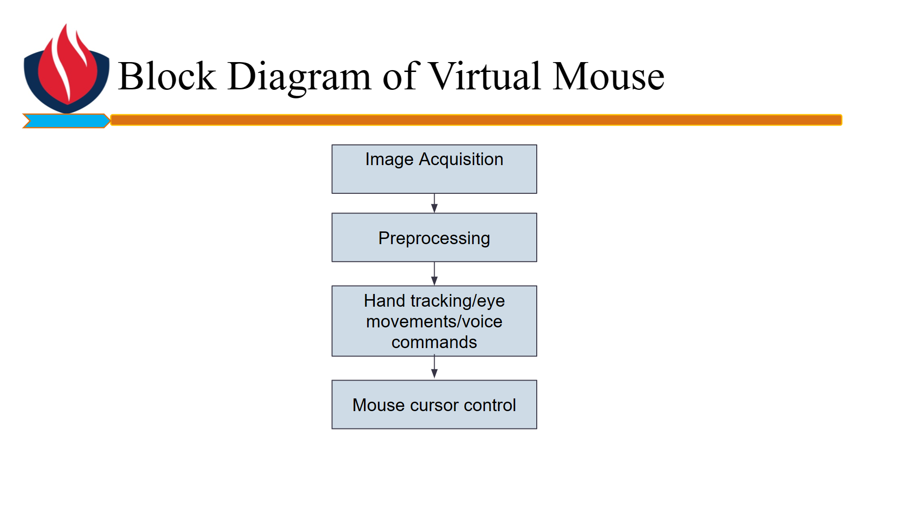

**Fig.3 Block Diagram of Virtual Mouse.**

**Virtual Keyboard**

By using a built-in camera or web camera to capture hand gestures, voice commands, and eye movement, the AI virtual keyboard system enables us to enter any text without having to interface with the system directly.

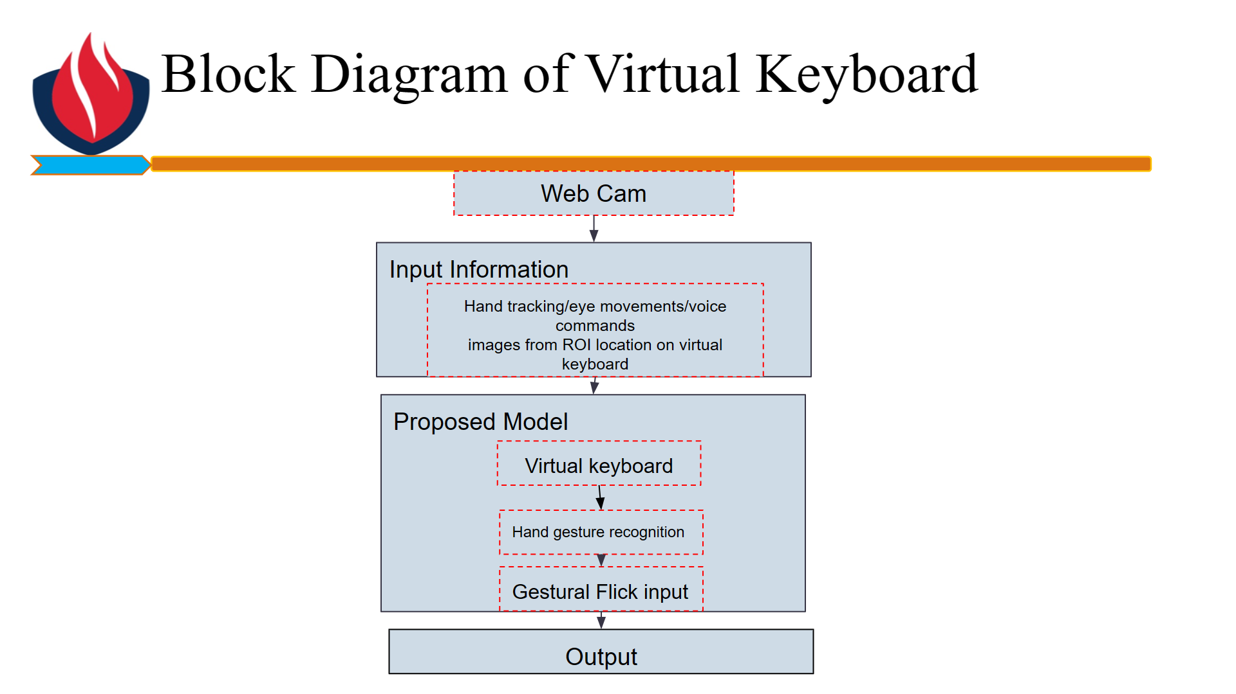

**Fig. 4 Block Diagram of Virtual Keyboard**